**Hotel Management Documentation**

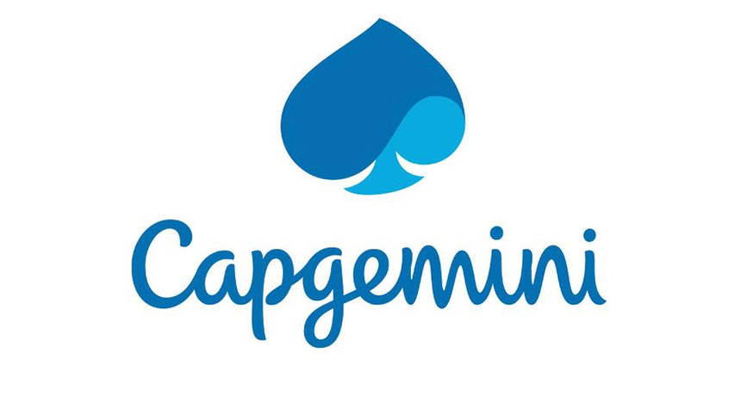

**Team Members :**

|  |  |
| --- | --- |
| Full Name | Employee ID |
| Pooja Rozara | 46022711 |
| Shubham Pal | 46022266 |
| Biyyapu Subhash | 46022121 |

Capgemini India Technology Services

IT Tower, A-1, MIDC Corner to IT Tower, M I D C Technology Park, Talwade, Pimpri-Chinchwad, Maharashtra 412114

Table of Contents

1. Introduction ------------------------------------------------------------------------------------
2. Overview-----------------------------------------------------------------------------------------
3. Team Member Work Allocation-------------------------------------------------------------
4. Epic & Stories -----------------------------------------------------------------------------------
5. Use Cases ----------------------------------------------------------------------------------------
   * 1. Product Management System -----------------------------------------------------------
6. Add a Product ---------------------------------------------------------------------
7. Edit a Product ---------------------------------------------------------------------
8. Delete a Product------------------------------------------------------------------
9. Add a Product Master------------------------------------------------------------
10. Search a Product------------------------------------------------------------------
11. Filter a Product -------------------------------------------------------------------
    * 1. Address Management System-----------------------------------------------------------

A) Add an Address--------------------------------------------------------------------

B) Update an Address----------------------------------------------------------------

C) Delete an Address-----------------------------------------------------------------

* + 1. Wishlist Management System -----------------------------------------------------------

A) Add a Product ---------------------------------------------------------------------

B) View Wishlist ---------------------------------------------------------------------

iv)Adding Item To cart------------------------------------------------------------------------

v)Placing the Order---------------------------------------------------------------------------

vi) Cancel Management System-------------------------------------------------------------

A) Cancel an Order--------------------------------------------------------------------

B) Cancel a Product-------------------------------------------------------------------

vii) Shelf Time Report------------------------------------------------------------------------

viii)User Management System-----------------------------------------------------------

A) User Registration--------------------------------------------------------------------

B) User Login----------------------------------------------------------------

C) User Logout-----------------------------------------------------------------

ix) Retailer Inventory Management System-----------------------------------------------

A) View Inventory

B) Update Receive Time

C) Update Sale Time

x) Go Admin Report Management System

A) Revenue Report

B) Growth Report

xi) Delivery Time Report --------------------------------------------------------------------

1. Class Diagram ----------------------------------------------------------------------------------
2. ER Diagram--------------------------------------------------------------------------------------
3. Test Case Scenario -----------------------------------------------------------------------------
4. BDD------------------------------------------------------------------------------------------------
5. Conclusion----------------------------------------------------------------------------------------

1. Introduction

Hotel reservations are a popular method for booking [hotel](https://en.wikipedia.org/wiki/Hotel) rooms. [Travelers](https://en.wikipedia.org/wiki/Travel) can book rooms on a computer by using [online security](https://en.wikipedia.org/wiki/Transport_Layer_Security) to protect their privacy and financial information and by using several online [travel agents](https://en.wikipedia.org/wiki/Travel_agent) to compare prices and facilities at different hotels.

Prior to the [Internet](https://en.wikipedia.org/wiki/Internet), travelers could write, telephone the hotel directly, or use a travel agent to make a reservation. Nowadays, online travel agents have pictures of hotels and rooms, information on prices and deals, and even information on local [resorts](https://en.wikipedia.org/wiki/Resorts). Many also allow [reviews](https://en.wikipedia.org/wiki/Review) of the traveler to be recorded with the online travel agent.

Hotel reservations are also helpful for making last minute travel arrangements. Hotels may drop the price of a room if some rooms are still available. There are several [websites](https://en.wikipedia.org/wiki/Websites) that specialize in searches for deals on rooms. Hotel Booking management System helps the users to book hotels and provide a convenient way for the hotel providers to maintain the records and to maximize their profit

2.Overview

This project aims to implement Hotel Booking management System. Hotel Booking management System helps the users to book hotels and provide a convenient way for the hotel providers to maintain the records and to maximize their profit. This system is robust and is an optimized version of the existing hotel booking system. This is an integrated System that contains 3 components user, hotel Employee and Admin.

All the three components or actors of the project can access the functionalities of the project once they login. Based on the login credentials the user interface is opened because all the three actors or users have different functionalities to perform and hence we provide different UI for different types of user.

The user component or actor is the main part of the project because user is the customer for the project. User can login or can register himself/herself and after entering the valid login credentials the user enter into the user UI where the list of hotels is shown. User can search for the hotels and check for the availability of the rooms and based on that can book the rooms. User have access to view all the booking transactions made till date by him/her.

Each Hotel is associated with a hotel employee and hotel employee is responsible for maintaining the record for the hotel rooms. Similar to the user, the hotel employee is needed to login before accessing the UI for the hotel employee. Hotel employee performs many functionalities. Hotel employee can see the booking transactions and he/she can also disable/enable the rooms based on the availability. One of the important or major functionality of the hotel employee is that he can book rooms in the offline mode also, that is he can make the reservation for the room when the user physically visit the hotel. Thus making the work of the hotel employee a lot easier. Hotel Employee allocates room to the user based on booking_id and can disable/enable any room on his/her associated hotel.

The last and important component or actor of the project is the admin. Admin is the person responsible for handling everything. Admin can add new hotels and can also delete hotels form the list of hotels. Admin updates the offers provided by the hotel or the organization handling the management system. Admin can view the reports in every possible way to study the booking pattern and to maximize profit. Like other components or actors admin also have to login before accessing the system.

3. Team Member Work Allocation

The project is having three components: user, hotel employee and admin. The work is divided based on the component or the actor.

User component or module is handled by Pooja Rozara

(employee id- 46022711)

Hotel employee component or module is handled by Biyyapu Subhash

(employee id- 46022121)

Admin module is handled by Shubham Pal

(employee id- 46022266)

4. Epic & Stories

|  |  |  |  |  |
| --- | --- | --- | --- | --- |
| Epic | Stories | As a/an | I want to | So that .. |
| Customer | Register | User | Register into the system | A new user is added to the database. |
| Login | User | Login to the system | I’m logged in to use my functionalities. |
| Search Hotels | User | Search for Hotel Rooms | To find a room suitable as per my requirements. |
| Book Hotels | User | Book Hotel rooms | I can book my preferred room. |
| View Booking Transactions | User | View My booking transactions | I can see my current booking status & Booking transaction history. |

|  |  |  |  |  |
| --- | --- | --- | --- | --- |
| Epic | Stories | As a/an | I want to | So that .. |
| Hotel Employee | Login | Hotel Employee | Login to the system using the credentials as provided by Hotel Booking company. | I’m logged in to use my functionalities. |
| Book Rooms | Hotel Employee | Book rooms of my own hotel. | I can book rooms of my hotel if there is an offline Customer. |
| View Booking Transactions | Hotel Employee | View my hotel’s booking transactions | I can see which rooms are booked for which dates, and which rooms are available for customers. |
| Enable & Disable Rooms | Hotel Employee | Toggle the availability of rooms in my hotel. | I can make certain rooms available or unavailable for online booking. |

|  |  |  |  |  |
| --- | --- | --- | --- | --- |
| Epic | Stories | As a/an | I want to | So that .. |
| Admin | Login | Admin | Login to the system | I’m logged in to use my functionalities. |
| Add Hotel  Delete Hotel | Admin  Admin | Add Hotels  Delete Hotels | New Hotels can be added to system’s database.  Hotels can be removed from the database. |
| Modify Hotel | Admin | Modify Hotels | I can update hotel details such as description. |
| Add Rooms | Admin | Add rooms | I can add new rooms in a hotel |
| Delete Rooms | Admin | Delete rooms | I can delete rooms from a hotel |
| Modify Room | Admin | Modify Room details | Update room details such as Price per night. |
| Update Offers | Admin | Update Offers on hotels and rooms | I can attract more customers |
| View Reports | Admin | View various booking reports | I can view list of available hotels, bookings of specific hotels, and bookings for specific dates |

5. Use Cases

5.1 User/Customer

Overview

The user component or actor is the main part of the project because user is the customer for the project. User can login or can register himself/herself and after entering the valid login credentials the user enter into the user UI where the list of hotels is shown. User can search for the hotels and check for the availability of the rooms and based on that can book the rooms. User have access to view all the booking transactions made till date by him/her.

Prerequisite

User must be logged in as customer/user to perform the view, search and book functionalities.

Search specific hotel, view booking transaction and booking hotel functionalities can be performed by any user.

Non Functional Requirement:

All modules are show designed that the result will be obtained within 10 seconds of request. Proper Loading indicator has been instantiated. Hence once a request been asked no one can further request anything. Authentication has been given a higher priority. All form validations are properly maintained. To make it more user friendly proper alert messages are shown wherever required. For instance if someone click on any other tab while filling up a form, our software will show a pop up alert – “all the data will be discarded” before navigation to the clicked tab. Pop message will also be shown during any action like delete add or edit product. Any changes in database will only be performed if user gives a confirmation to those pop up warnings.

Designed and Implemented By:

Pooja Rozara ( Id : 46022711)

Designation : Senior Analyst/ A5

Use Case Diagram for User/Customer

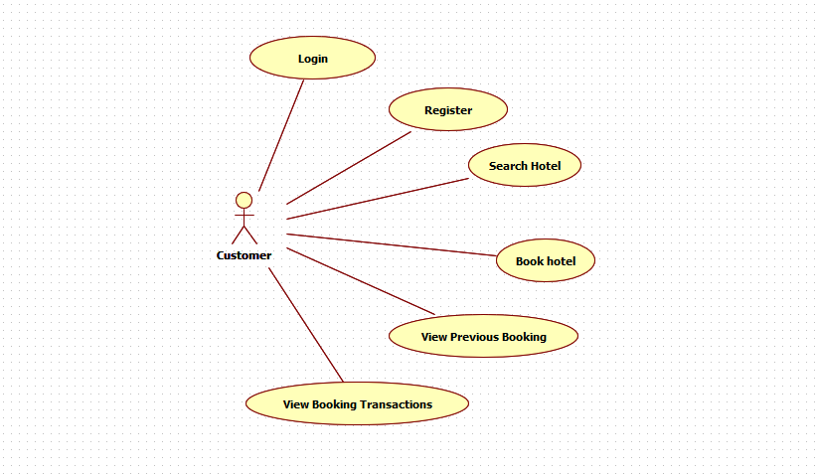

* Register:

The registration from takes in inputs from the user like their name, dob etc. and store this information in the system database. The user is required to register in the system before they can start using its functionalities.

* User Login:

Once the user has registered, a customer Id is allocated to them which would be used to login to the system. The login form uses authorization mechanism, so that user can only perform customer functionalities like searching for rooms, booking for rooms and viewing booking status.

* Search Hotel:

Following successful login, customer can now search hotels to find a room suitable as per their requirements. User can also search hotels based on location & services provided by the hotel. For example: AC rooms/ Non-Ac rooms.

* Book Room:

This functionality allows the customer to book room in their preferred hotel. User can search hotel according to preference and then can book room.

* View Booking Transactions:

User can view the bookings made by him/her till date. From this, user will be able to know how many rooms he/she have booked along with the period of stay.

In this, user will be able to see the bookings which were cancelled due to any reasons.

Sequence Diagram for User/Customer

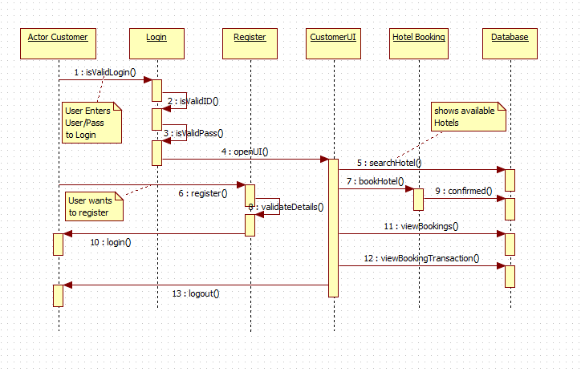

5.2 Hotel Employee

Overview

Each Hotel is associated with a hotel employee and hotel employee is responsible for maintaining the record for the hotel rooms. Similar to the user, the hotel employee is needed to login before accessing the UI for the hotel employee. Hotel employee performs many functionalities. Hotel employee can see the booking transactions and he/she can also disable/enable the rooms based on the availability. One of the important or major functionality of the hotel employee is that he can book rooms in the offline mode also, that is he can make the reservation for the room when the user physically visit the hotel. Thus making the work of the hotel employee a lot easier. Hotel Employee allocates room to the user based on booking_id and can disable/enable any room on his/her associated hotel.

Prerequisite

User must be logged in as Hotel Employee to perform the Booking, Cancel Booking, Enable/Disable room, view status of the rooms, allocate rooms for online transactions functionalities.

Non Functional Requirement:

All modules are show designed that the result will be obtained within 10 seconds of request. Proper Loading indicator has been instantiated. Hence once a request been asked no one can further request anything. Authentication has been given a higher priority. All form validations are properly maintained. To make it more user-friendly proper alert messages are shown wherever required. For instance if someone click on any other tab while filling up a form, our software will show a pop up alert – “all the data will be discarded” before navigation to the clicked tab. Pop message will also be shown during any action like delete add or edit product. Any changes in database will only be performed if user gives a confirmation to those pop-up warnings.

Designed and Implemented By:

Biyyapu Subhash (Id : 46022121)

Designation : Senior Analyst/ A5

Use Case Diagram for Hotel Employee

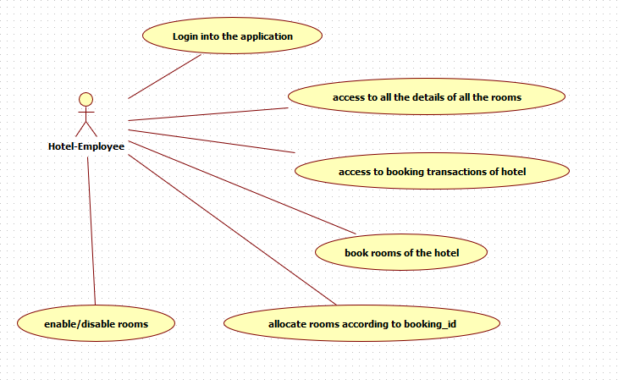

* Allocate room based on booking_id:

When a user books a room/rooms, booking_id is generated for that transaction.A user must give that booking_id to hotel Employee when he/she checks in to the hotel.Then the hotel Employee checks for the available rooms based on booking dates ,type of the room which were extracted based on booking_id.From the available rooms,hotel Employee assings a room to user and subsequently the row in booking table gets updated with room_id.

* Book a room(offline):

A hotel Employee can book a room in offline too.He checks the availability of rooms based on the customer's booking dates and books rooms/room. A new row gets inserted in the bookings_table .

* Disable/Enable Room:

A hotel Employee can enable or disbale a room ,which gets refelected in the database.So a person ,booking online also finds a change in the rooms' list.The availibilty column gets updated whenever hotel employee changes the room status.

* View Status of the room:

Hotel Employee can view the status of each room in his/her hotel date wise.

Data is retrieved based from the booking_table and is displayed on the UI page.

* View Transactions:

A hotel Employee can view all the transactions of associated hotel.

The data is retrieved from bookings_hotel.

Sequence Diagram for Hotel Employee to book offline:

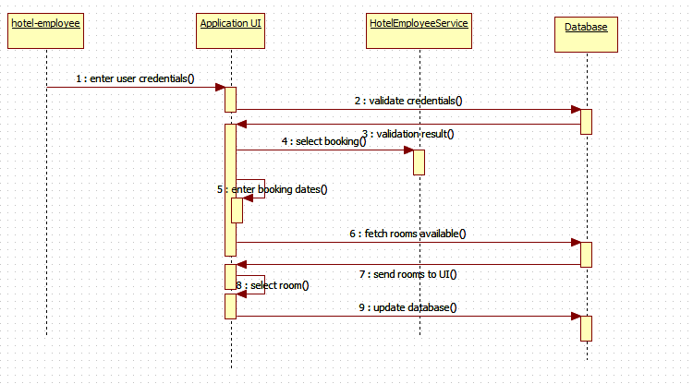

Sequence Diagram for Hotel Employee to allocate room based on online booking_id:

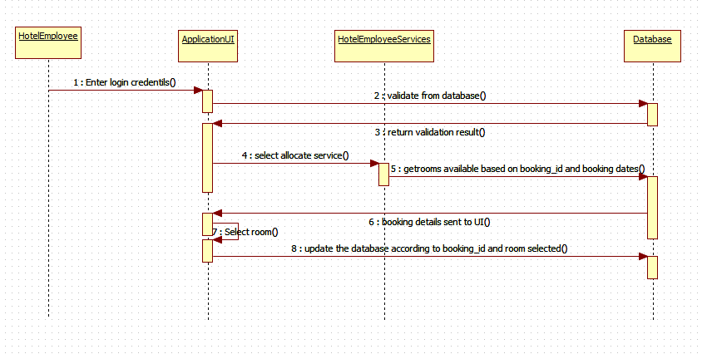

5.3 Admin Module

Overview

Admin module is the core in any online system as admin has the full control over the system. Logging-in, Adding Hotels, deleting hotels, adding rooms, deleting rooms, updating offers, generating reports like list of hotels, bookings of specific hotels, bookings of specific dates come under this module. Our software uses authorization so that only authorized admin can use the admin functionalities, i.e Role Mapping.

Designed and Implemented By:

Shubham Pal ( Id : 46022266)

Designation : Senior Analyst/ A5

Use Case Diagram for Admin :

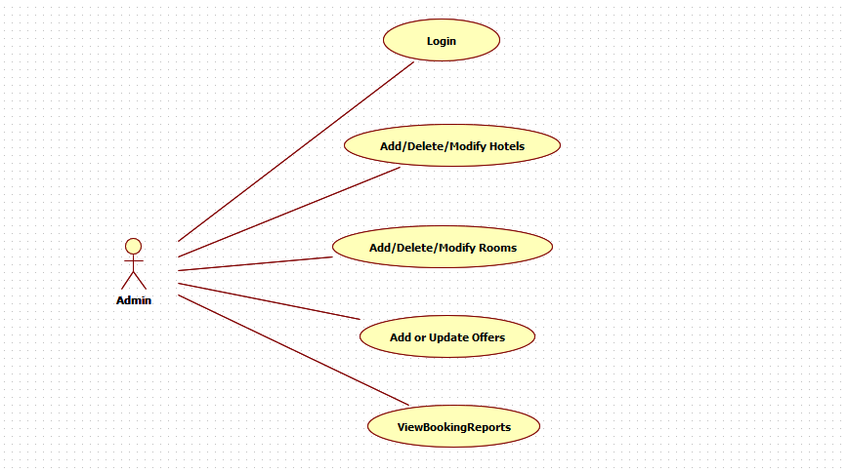

* Admin Login

The form uses authorization mechanism, so that only the authorized user can perform admin functionalities.

* Add / Delete/ Modify Hotels

The “Add Hotel” functionality is designed to add new Hotels into the System Database.

The “Delete Hotel” functionality is designed to delete an existing hotel from the System Database.

The “Modify Hotel” functionality is designed to update hotel details such a Hotel Description, Rooms etc.

* Add/ Delete/ Modify Rooms

The “Add Room” functionality is designed to add new rooms in an existing hotel.

The “Delete Room” functionality is designed to delete a room from an existing hotel.

The “Modify Room” functionality is designed to update room details such as price per night etc.

* Update offers

This functionality is designed to add or update offers on hotel and room prices.

* View Booking Reports

This functionality is designed to generate various type of reports, namely,

List of hotels

Bookings of specific Hotels

Bookings of specific dates

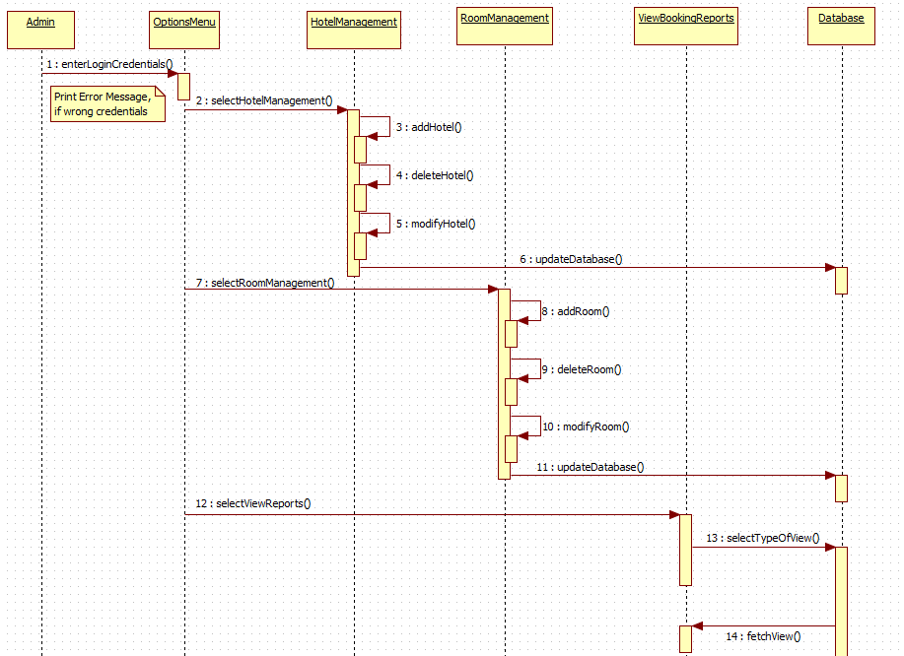Sequence Diagram Admin :

10. System Requirements

Below is a list of the minimum Hardware and Software requirements to access Great Outdoors website.

**Operating System:**

* Windows 7 and above.
* Mac OSX 10.8, 10.9, 10.10 or 10.11
* Android 3 and onwards.

**Hardware:**

* Processor (CPU) with 2 gigahertz (GHz) frequency or above
* A minimum of 4 GB of RAM
* Monitor Resolution 1024 X 768 or higher (For better view)
* A minimum of 5 GB of available space on the hard disk
* Internet Connection Broadband (high-speed) Internet connection with a speed of 2 Mbps or higher
* Keyboard and a Mouse or some other compatible pointing device

**Browsers:**

* Chrome* 58+
* Microsoft Edge* 20+
* Mozilla Firefox 40+
* Internet Explorer 11+ (Windows only)
* Safari 6+ (MacOS only)
* Android* 3+

*\**Google Chrome version 42+ and Microsoft Edge do not support NPAPI-type plug-ins, including Java plug-ins and many media browser plug-in.

*Users using unsupported browsers may experience issues submitting forms, placing orders, purchasing, updating details and transaction management threads.*

**Browser Configuration:**

Your browser must be configured as follows:

* **Strongly Recommended--**add [www.greatoutdoors.com](http://www.greatoutdoors.com/) to trusted sites.
* JavaScript must be enabled
* CORS must be configured properly
* Cookies must be enabled.
* Pop-up windows must be enabled.

**Software:**

* Java — to view and interact with all available blackboard applications.
* Eclipse — Eclipse workbench was used to run JDK (write, compile and run the code).
* Visual Studio Code — for writing codes for frontend using angular, VS Code was used as a workbench.
* Apache Tomcat — it was used as a server for hosting the website.